World War One
Year 2
By the end of this unit children will know…
- Understand the key dates in WW1
- Find out what life would have been like for a child living in WW1 and compare with their own lives today.
- Find out about the Christmas truce and Princess Mary’s Christmas Boxes that were sent to the troops in WW1.
- Design and make their own medals for bravery.
- Understand the key individuals in WW1 – leaders etc.

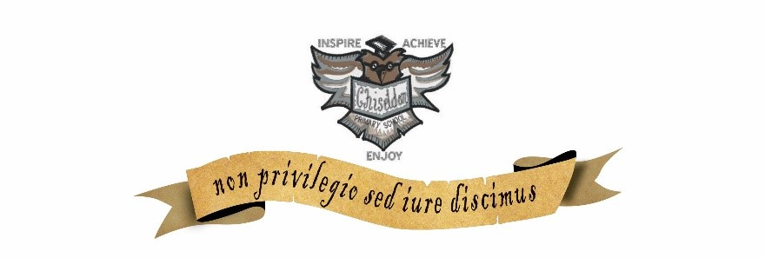

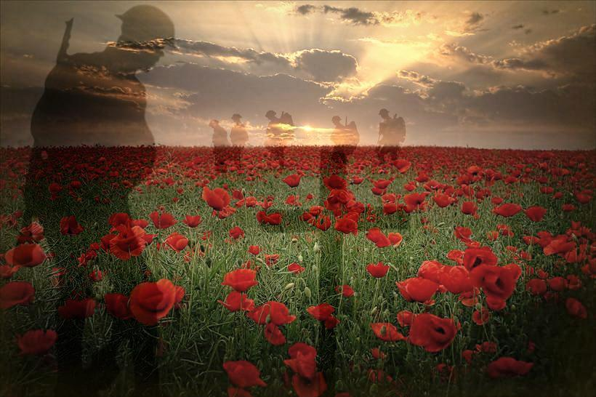

Intent | Implementation | Impact | Celebrate
To understand they key dates and events that led up to the first World War.  To understand what the Christmas truce was and what Princess Mary did to help.  To understand how the job roles changed and the work women had to do. | Create timelines and highlight the countries that where allies and enemies.  To describe what the Christmas Truce was, why it happened and the consequences of it.  To create medals like the WW1 soldiers would have had/been given. | To have an understanding of the key dates in WW1, stating when it started and ended.  To be able to explain which countries participated and which were our allies.  To be able to create purposeful medals. | Their own celebratory party like the one at the end of WW1, creating their own flags and singing WW1 songs.
WW1: Year 2 : Knowledge Content
Personal Development | Foundation Subjects
Spiritual | History & Geography
Does going to a mosque give Muslims a sense of belonging?  Islam | History  - Children research the past to create a timeline of events  - Children find out what life would have been like for a child living in WW1 and compare with their own lives today.  - Find out about Princess Mary’s Christmas Boxes that were sent to the troops in WW1.  - Find out about the Christmas Truce of 1914.  - Understand the key individuals in WW1 – leaders etc.  Geography  - Children use maps to identify continents, oceans and key countries involved in the First World War.
Moral | Art & Design and Design Technology
Relationships – Different families, keeping safe and the roles our friends have. | Art/Design Technology  - Children design and make their own medals for bravery.
Social | Music and Languages
How to deal with conflict within our relationships. | Music  To continue learning their musical instrument, the Ukulele.  Languages  Re-cap Chapter 3 Children should be able to name animals you would find at the Zoo and the noises they make.
Cultural | Physical Education
Celebrating different relationships and families. | Use kicking skills in a game Use dribbling skills in a game Begin to choose and use the best space in a game Begin to use the terms attacking and defending Understand the importance of rules in a game

Core Subjects:
Links to theme
English
To follow the Jane Considine planning on writing a poem.

Mathematics
Time - Compare and sequence intervals of time tell and write the time to five minutes, including quarter past/to the hour and draw the hands on a clock face to show these times know the number of minutes in an hour and the number of hours in a day
Shape - Identify 2-D shapes on the surface of 3-D shapes, a circle on a cylinder and a triangle on a pyramid, for example
Science
Sc2/2.2a observe and describe how seeds and bulbs grow into mature plants
Computing
Children use ICT to support research and to present and publish their work.

Core Subjects:

English
- To read and understand the layout of a poem.
- To write, review and improve.
- Follow the layout of non-fiction text.
Mathematics
- Identify and describe the properties of 2-D shapes, including the number of sides and line symmetry.
- Identify and describe the properties of 3-D shapes, including the number of edges, vertices and faces.
- Tell and write the time to five minutes, including quarter past/to the hour and draw the hands on a clock face to show these times.
- Know the number of minutes in an hour and the number of hours in a day.
Science
- Observe and describe how seeds and bulbs grow into mature plants.
Computing
- Create and debug simple programs
- To predict outcome of simple programs.
WW1: Year 2 : Links to National Curriculum Framework Skills
Foundation Subjects
History & Geography
History
- Use dates where appropriate.
- Label time lines with words such as past, present, older and newer.
- Ask questions such as: what was it like for people? What happened? How long ago?
- Use artefacts, pictures, stories, online sources and databases to find out about the past.
- Use words such as: a long time ago, recently, when my parents/carers were children, years, decades and centuries to describe the passing of time.
- Show an understanding of the concept of nation and a nation’s history.
- Show an understanding of concepts such as civilization, monarchy, parliament, democracy and war and peace.
- Identify some of the different ways that the past has been represented.
- Recognise that there are reasons why people in the past acted as they did.
- Ask questions such as; what was it like for people? What happened? How long ago?
Geography
- Use world maps, atlases and globes to identify the United Kingdom and its countries, as well as the countries, continents and oceans studied.
Art & Design and Design Technology
Art and Design
- Use a combination of materials that are cut, torn and glued.
- Sort and arrange materials
- Sketch, shade and colour
Music and Languages
- Music - Take part in singing, accurately following the melody, playing cords and simple tunes.
- German – Accurately form simple sentences in a MFL
Physical Education
- Participate in team games, developing simple tactics for attacking and defending

Core Subjects:

English
Children read for information and will produce writing in a variety of genres - Diaries, Recounts, Information / explanation and personal view points.
Mathematics
- Children demonstrate that they can solve simple maths problems related to time.
- Discrete Maths Assessment.

Science
Discrete Science Assessment and experiment with their own plants.
Computing
Children demonstrate that they can use ICT to support research and to present and publish their work.

WW1 : Year 2 : Core Skills/Assessment Opportunities
Foundation Subjects
History & Geography
History
- Children demonstrate their understanding of key historical vocabulary and chronological understanding through timelines
- Children demonstrate an understanding on key figures in British History and the part that they played in the First World War.
- Through their work based around Christmas and the Princess Mary Christmas boxes, children demonstrate an understanding of what life was like in the trenches and the equipment that they would need.
- Children demonstrate understanding of a key event in British History through their work on the Christmas Truce of 1914.
Geography
- Through their map work, children demonstrate that they can identify oceans, continents and key countries involved in World War One.
Art & Design and Design Technology
Art/Design Technology

- When making medals, children demonstrate that they can use techniques such as moulding and carving on a range of materials.
Music and Languages
- Music - Record and perform their Ukulele for their parents and partner class.
- German - To have simple conversations with each other in German on animals.
Physical Education
- To peer review one another
- To transfer skills to other games

English
Text Type | Text Structure | Sentence | Useful Vocabulary | Word Classes
Poetry |  | Use expanded noun phrases for description and specification e.g. the blue butterfly, plain flour, the man in the moon. (Vocabulary, Grammar and Punctuation)  Understand how the grammatical patterns in a sentence indicate its function as a statement, question, exclamation or command. (Vocabulary, Grammar and Punctuation)  Form adjectives using suffixes such as -ful, -less  Use suffixes -er, -est in adjectives and use -ly to turn adjectives into adverbs e.g. smoothly, softly, bigger, biggest. | Objects and specific language used to describe what they have lost. | Adjectives – delightful, terrifying, joyful etc  Verbs – The actions of the object lost .  Adverbs – quickly, slowly etc
  Write for different purposes to develop positive attitudes and stamina for writing.
  Consider what he/she is going to write before beginning by writing down ideas and/or key words, including new vocabulary.
  Consider what he/she is going to write before beginning by encapsulating what he/she wants to say, sentence by sentence.
  Make simple additions, revisions and corrections to his/her own writing by evaluating their writing with the teacher and other pupils.

Mathematics
Number | Calculation | Fractions | Shape & Measure | Data
 | Time  Compare and sequence intervals of time tell and write the time to five minutes, including quarter past/to the hour and draw the hands on a clock face to show these times know the number of minutes in an hour and the number of hours in a day |  | Shape  Identify 2-D shapes on the surface of 3-D shapes, a circle on a cylinder and a triangle on a pyramid, for example | Statistics  Ask and answer questions about totalling and comparing categorical data.

