Lights, Camera, Action
Year 5
By the end of this unit children will understand…
- The history of film including silent films, animation, the golden age of film and modern film.
- Know influential filmmakers
- Historical pioneers of film
- How to develop their narrative skills by creating their own stories for film


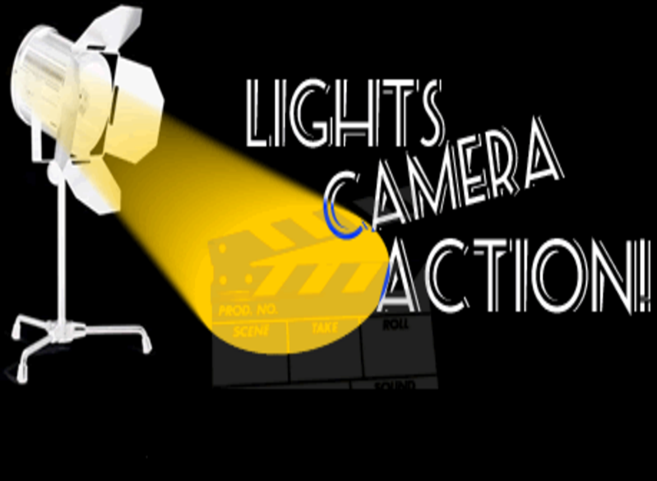
Intent | Implementation | Impact | Celebrate
During this topic, children will use and enhance their own knowledge of film and deepen their understanding of the origin of film. They will look at different resources including film, art and biographies to research films and filmmakers.  Alongside this, they will create art inspired by films and Hollywood. |  | Children will be able to showcase their creativity during this topic in order to develop their own film. They will be able to work collaboratively with peers to share their ideas and respond to feedback. Children will be able to use their designs as a basis to write for a range of purposes across the curriculum. | Hook day with dressing as film characters and activities provided to engage and excite the children.  Films/animations made and opportunities to share and celebrate.  Weekly updates on the school website showing our achievements.
  The children will form their own line of enquiry based on their interests to create their own reviews of films.
  They will have time to watch and critique a range of films stretching from the 20th century to now alongside learning about pioneers of each era.
  They will take inspiration from influential filmmakers to create their own artwork.
Lights, Camera, Action: Year 5: Knowledge Content
Personal Development | Foundation Subjects
Spiritual | - History & Geography
Sikhism  How far would a Sikh go for his/her religion? | History:  - To generate questions to find out about events in the past, when did filmmaking begin? What was the first type of film?  - To sequence events on a timeline  - To understand the importance early filmmaking had on today’s film  - To understand how films reflected the society they were made in/for
Moral | Art & Design and Design Technology
Making the right choice | - Design a Hollywood Walk of Fame star  - Create a Tim Burton inspired movie character
Social | Music and Languages
Celebrating differences including from different eras of film. | Music: Trumpet  German: Recap greetings, music and celebrations, forming opinions.
Cultural | Physical Education
Following and understanding the changes throughout history. | Fundamentals:  Ball Skills including Netball.

Core Subjects:
Links to theme
English
- Narrative based on The The Fantastic Flying Books of Mr Morris Lessmore by William Joyce.
Children will use the picture book as a stimulus for writing.

- Book Talk: Varjak Paw
Mathematics
- Place value of 6 digit numbers.
- Roman numerals to 1000
- Decimals up to 3 decimal places
- Shape nets
Science
Living things and their
habitats: Life Cycles
Computing
- Video editing – Making and editing a film

Core Subjects:

English
- Select appropriate grammar and vocabulary, understanding how such choices can change and enhance meaning
- Assess the effectiveness of their own and others’ writing
- Propose changes to vocabulary, grammar and punctuation to enhance effects and clarify meaning
Mathematics
- Read, write, order and compare numbers to at least 1,000,000 and determine the value of each digit.
- Read, write and represent decimal numbers with up to 3 places.
- Round decimal numbers
- Identify cubes, cuboids, prisms and pyramids from nets.
Science
- Describe the differences in the life cycles of a mammal, an amphibian, an insect and a bird.
- Describe the life process of reproduction in some plants and animals
Computing
- understand computer networks including the internet; how they can provide multiple services, such as the world wide web; and the opportunities they offer for communication and collaboration
Lights, Camera, Action: Year 5: Links to National Curriculum Framework Skills
Foundation Subjects
History & Geography
History
Use sources of evidence to deduce information about the past.
Describe the main changes in a period of history.
Use dates and terms accurately in describing events.
Use appropriate historical vocabulary to communicate e.g. legacy, continuity. Use original ways to present information and ideas.
Art & Design and Design Technology
- Collect information, sketches and resources and present ideas imaginatively in a sketch book.
- Choose a style of drawing suitable for the work. Combine colours, tones and tints to enhance the mood of a piece
- Select from and use a wider range of materials and components including constructional materials, textiles and ingredients, according to their functional properties and aesthetic qualities
Music and Languages
- Play and perform using musical instruments with increasing accuracy, fluency, control and expression
- Broaden vocabulary and develop the ability to understand new words that are introduced into familiar written material, including through using a dictionary
Physical Education
- Perform with confidence, using a range of movement patterns.
- Move appropriately and with the required style in relation to the stimulus, e.g. using various levels, ways of travelling and motifs.
- Orientate themselves as part of a team around a course with confidence and accuracy when under pressure Design an orienteering course that is clear and gives challenge

Core Subjects:

English
- Children will write a narrative in the style of ‘The Fantastic Flying Books of Mr Morris Lessmore’ by William Joyce thinking about how they could change the characters and adapt the plot.
- Children will answer questions around a text using evidence and explanation.
Mathematics
- Daily assessment through live marking and ‘do, secure, deepen’ approach
- End of unit quizzes to assess what chn have learnt from each unit
- Re-cap learning from Year 4 in MOT sessions.
Science
- End of unit Quiz
Computing
- End of Unit Quiz
- Children will be able to explain how video editing works
Lights, Camera, Action: Year 5: Core Skills/Assessment Opportunities
Foundation Subjects
History & Geography
History
- Children will create a timeline of significant film eras.
- Children will write a biography of Steven Speilberg.
- Children will watch silent films, original films and modern films and make a personal judgement of them.

Art & Design and Design Technology
- Children will think of a colour scheme for their character by experimenting with colour and texture using a mood board.
- Children will draft and design a character brand including a name and character quirk.
- Children will take inspiration and include key elements from the original Hollywood Star.
Music and Languages
- Children will play and perform using musical instruments with increasing accuracy, fluency, control and expression – children will make connections between pieces of music
- Children will be able to communicate positive and negative personal opinions in German.
Physical Education
- Children will display skills learnt during the term in games of netball.

English
Year Five
Term 1 | Narrative | Sequence of plot may be disrupted for effect  e.g. flashback  Opening and resolution shape the story  Structural features of narrative are included  e.g. repetition for effect  Paragraphs varied in length and structure.  Pronouns used to hide the doer of the action e.g. it crept into the  woods | Sentence length varied e.g short/long.  Active and passive voice used deliberately to heighten engagement.  e.g. the ring was removed from the drawer  Wide range of subordinate connectives  e.g. whilst, until, despite.  Embedded subordinate clauses are used for economy or emphasis  Figurative language used to build description (sometimes clichéd) e.g. the crowd charged like bulls  Repetition is used for effect e.g. the boys ran and ran until they could run no more. | Year 5 ambitious vocabulary used | Noun  Locate and identify expanded noun phrases.  Verbs  Use modal verbs.  Prefixes for verbs; dis, de, mis, over, ise, ify.  Convert adjectives in verbs using suffixes; ate, ise, ify.  Adjectives  Choose appropriate adjectives  Connectives/conjunctions  Use a wide range of connectives.  Tense  Change tense according to features of the genre.  Adverbs  Know what an adverbial phrase is.  Fronted adverbials  Comma after fronted adverbials.  Adverbials of time, place and number.

Mathematics
Number | Calculation | Statistics | Shape & Measure | Ratio and Proportion
