Neil Armstrong
Year 2
By the end of this unit children will know…
- Events beyond living memory that are significant nationally or globally, in particular the space race and Neil Armstrong’s journey to the moon

- Will know about significant individual (Neil Armstrong) who in the past has contributed to national and international achievements.

- Understand changes within living memory and where appropriate use these to reveal aspects of change in national life.



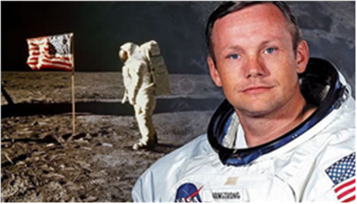

Intent | Implementation | Impact | Celebrate
To develop the significant understanding of Neil Armstrong and how his influence has contributed to space travel on a national and international level.  Drawing on children’s previous knowledge of historical events and how this fits chronologically into history.  Through scientific enquiry, the children will be able to answer what materials would be suitable for their own parachute and why? | Children will look specifically at the influence of Neil Armstrong.  The children will look at Neil Armstrong and how he moved on the moon and link this to Physical Education.  Children will investigate materials and decide on the best material for their parachute. | Children will begin to understand the life of Neil Armstrong and the influence of his life.  The children will have a key understanding an historical event.  Children will have designed and made a parachute and made evaluative decisions about their designs throughout. | The children will be able to talk about Neil Armstrong making reference to his influence on space travel today.  Children will get to launch their parachute to evaluate the effectiveness of their parachute.
Title of Topic: Neil Armstrong Year: 2 Knowledge Content
Personal Development | Foundation Subjects
Spiritual | History & Geography
Jesus as a gift from God - Why do Christians believe God gave Jesus to the World? | - To generate questions to find out about events in the past, what did Neil Armstrong do to make history?  - To sequence events on a time line  - To understand the importance Neil Armstrong had on history  - To understand the cause and effect this event had on the world and how we look at space travel and beyond
Moral | Art & Design and Design Technology
How to help our friends when someone is being bullied | - To make a parachute out of a variety of materials  - To design and reflect on their parachute design and material choice
Social | Music and Languages
Celebrating differences between genders | Music  - Continue to learn to play the ukulele without music teacher  - Perform in the Christmas play  German  - My School day, In the classroom and Opinions about school units
Cultural | Physical Education
What does the Christmas story mean to us as individuals? | Learn a dance and explore the enjoyment of free movement Children will explore creating patterns to add to their dance
Core Subjects:
Links to theme
English
Recount
Identifying what has happened and why it has happened. Linking it to Neil Armstrong and why they went to space and how
Mathematics
Addition and Subtraction
Geometry – properties of shape
Science
To continue developing their understanding of Materials and their properties
Plan an investigation around suitable materials for a parachute and evaluate along the way
Computing
Learners will learn to recognise that different devices can be used to capture photographs and will gain experience capturing, editing, and improving photos. Finally, they will use this knowledge to recognise that images they see may not be real.

Core Subjects:
English
Ask and answer questions about texts linked to Neil Armstrong.
Explain and discuss understanding of texts
To utilise the information learnt and apply it within their writing when looking into Neil Armstrong.
To organise writing in-line with its purpose
Mathematics
Addition and subtraction – using different methods to work out problems and know which method to use each time
Geometry – properties of shape
Science
Children to demonstrate an understanding of materials.
Children to be able to describe the properties of a material.
To describe what material would be suitable and why.
Computing
Learners will learn to recognise that different devices can be used to capture photographs and will gain experience capturing, editing, and improving photos. Finally, they will use this knowledge to recognise that images they see may not be real.

Title of Topic: Neil Armstrong Year: 2 Links to National Curriculum Framework Skills
Foundation Subjects
History & Geography
History:
- Look at the lives of significant individuals in Britain’s past who have contributed to our nation’s achievements—scientists such as Isaac Newton or Michael Faraday, reformers such as Elizabeth Fry or William Wilberforce, medical pioneers such as William Harvey or Florence Nightingale or creative geniuses such as Isambard Kingdom Brunel or Christina Rossetti
- Place events and artefacts in order on a timeline
- Label timelines with words or phrases such as; past, present, older and newer
- Use dates where appropriate
Art & Design and Design Technology
Design Technology:
- Design purposeful, functional appealing products for themselves and other users based on design criteria
- Generate, develop, model and communicate their ideas through talking, drawing, templates, mock-ups and, where appropriate, information and communication technology
- Cut materials safely using tools provided
Music and Languages
Music:
- Create a sequence of long and short sounds
- Create a mixture of different sounds (long and short, loud and quiet, high and low)
- Choose sounds to create an effect
- Sequence sounds to create an overall effect
German:
- Know words for the school day, in the classroom and opinions about school
Physical Education
P.E:
To perform dances using simple movement patterns

Title of Topic: Neil Armstrong Year: 2 Core Skills/Assessment Opportunities
Foundation Subjects
History & Geography
History:
- Sequence ideas and events on a timeline, including reference to key dates around the space race
- Conduct key historical research to find out about the different lives of key individuals from the past, identifying how they have shaped history in particular Neil Armstrong

Art & Design and Design Technology
Design Technology:

- Design and make a parachute using different materials, reviewing their design at various spoints during the design and making process
- Children will create a plan for their design thinking carefully about the materials available.
Music and Languages
Music:
- Children can play a piece of music on the ukulele
- Learn and perform the Christmas songs.
German
- Languagenut units: 7.4 My School day, 7.5 In the classroom and 7.6 Opinions about school
Physical Education
Create a dance inspired by space. How we would move and act if we lived with no gravity. To perform the dance ensuring that they meet all the criteria.

Core Subjects:

English
Write questions for an interview with an astronaut.
Create a persuasive poster about being an astronaut.
Mathematics
See following Mathematics page for assessment opportunities including addition and subtraction facts and methods to use to solve problems

Geometry of shape – properties of shape

Science
Properties of materials unit
Plan and evaluate an investigation around materials suitable for a parachute

Computing
Use a range of applications and devices in order to present the work throughout the topic.

English
Text Type | Text Structure | Sentence | Useful Vocabulary | Word Classes
Recount | Write to retell an event or an experience.  To think about the description and accuracy of the writing when retelling a historic event.  Consider what he/she is going to write before beginning by writing down ideas and/or key words, including new vocabulary.  Consider what he/she is going to write before beginning by encapsulating what he/she wants to say, sentence by sentence. | Make simple additions, revisions and corrections to his/her own writing by evaluating their writing with the teacher and other pupils.  Form lower-case letters of the correct size relative to one another in some of his/her writing.  Use the diagonal and horizontal strokes needed to join letters in some of his/her writing.  Write in the past tense. I went, I did, they said and they did etc. | Use expanded noun phrases for description and specification e.g. the blue butterfly, plain flour, the man in the moon. (Vocabulary, Grammar and Punctuation)  Understand how the grammatical patterns in a sentence indicate its function as a statement, question, exclamation or command. (Vocabulary, Grammar and Punctuation)  Form adjectives using suffixes such as -ful, -less  Use suffixes -er, -est in adjectives and use -ly to turn adjectives into adverbs e.g. smoothly, softly, bigger, biggest. | Adjectives – Describing what has happened in the past.  Pronouns – to identify who did what in the past tense – she did, he did and we did.  Continue developing their ability to use conjunctions when writing sentences – because, but and or.

Mathematics
Number | Calculation | Fractions | Shape & Measure | Data
 | 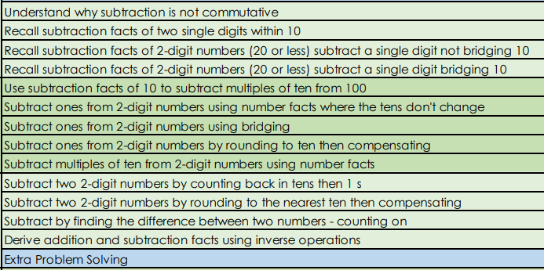  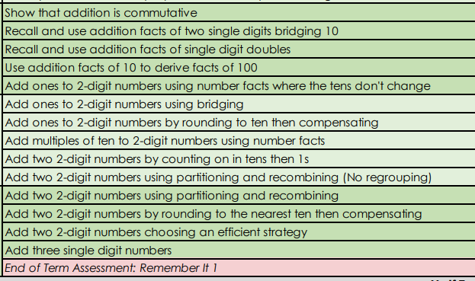 |  | 